STEP ONE: BOOK YOUR SEAT(S) OR TABLE(S)

Check below and indicate the number of tables or seats to be booked.
NO. OF TABLES / SEATS | PRICE*
x TABLES | x KRW 2,190,000 / TABLE
x SEATS | x KRW 365,000 / SEAT

NOTE 1. Registration deadline: January 15th

NOTE2. The registration will be on the first-come first-served basis.

NOTE 3. One table will be arranged for 6 people only, under covid-19 regulations implemented by Korean Government. For bookings under 6 people, a table will be arranged with other guests.

NOTE 4. Cancellations must be notified only before January 15th. Cancellation after the deadline or no-shows will be charged accordingly.

NOTE 5. All prices are subject to 10% VAT.

NOTE 6. You can complete your payment upon receipt of the invoice by FKCCI. Payment can be made to the FKCCI’s bank account only by no later than January 22nd. (Shinhan Bank, n° 140-009-492957)
NOTE 7. No entry without invitation.

NAME COMPANY EMAIL
PHONE FAX

STEP TWO: SEND YOUR TABLE CHART

We kindly request you to provide the seating arrangements no later than January 22nd by fax or email. In case of individual reservation, please be aware that your preference of seats cannot be guaranteed.
Please kindly fill the seating chart indicating precisely the name of each guests and ensure the names are correct. Names will be printed out as registered on this form.
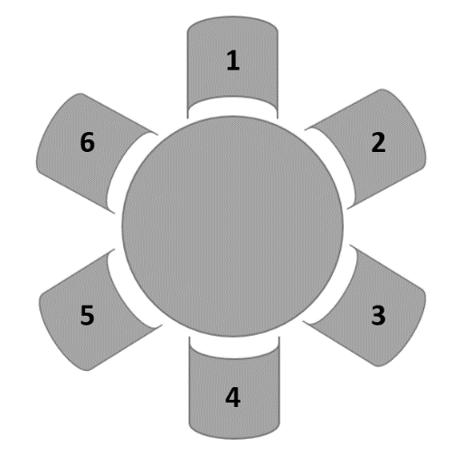
Due to COVID-19 regulations emitted by the Korean Government, all information shall be fully registered in advance (full name, phone number, residence location) in order to be allowed to enter any event.
Therefore, FKCCI is asking for your cooperation in providing exact information for each guest to attend the Charity Gastronomic Dinner. Any guest which hasn’t been identify with all those information won’t be allowed to enter the venue. 4 weeks after the event, FKCCI will erase this list as it’s legally required by the Korean Government rules currently implemented. This could be changed in consideration of a new regulation.

Seat Number & Name  - Choose an item.  - Choose an item.  - Choose an item.  - Choose an item.  - Choose an item.  - Choose an item. | Phone Number* | Residence*
TOTAL NUMBER OF SEATS
Example:
Seat Number & Name  - Mr. HONG Gil-Dong | Phone Number*  - 010-2345-6789 | Residence*  - Seoul, Gangnam-gu

If you reserve more than one table, please indicate the total number of tables, and send us the corresponding number of forms.
TABLE NUMBER OUT OF (e.g. Table number 1 out of 3)

